Student Research Card — MS. Le Lit

1. Basic info
- Name: Le Lit
- Role: Master Student
- Profile photo:
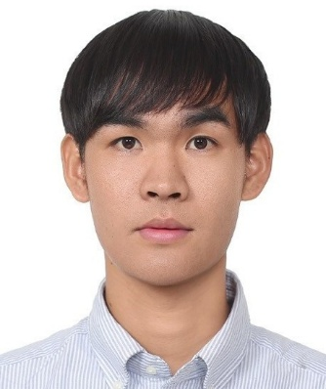

2. Research summary
- Research title: Physics-Guided AI and Multi-Objective Optimization for Advanced PEMFC Flow-Channel Design
- Research figure:
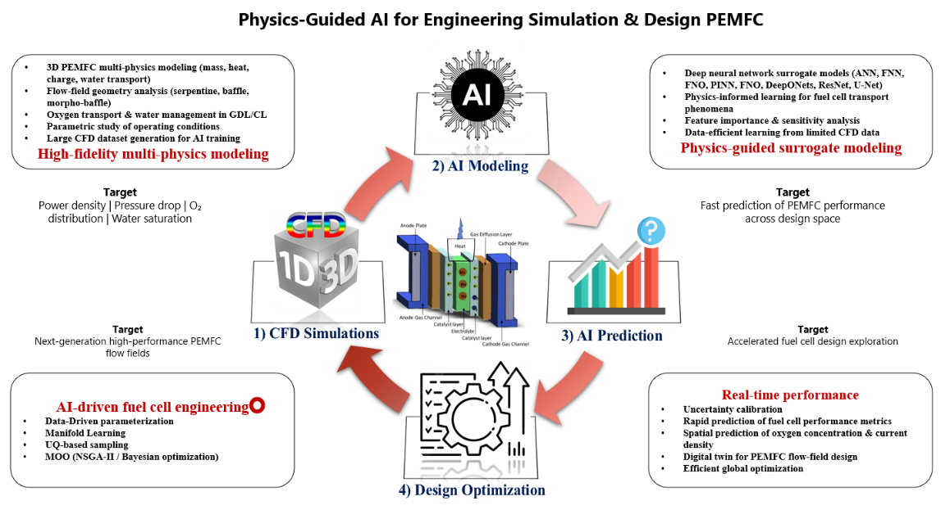
- Description: I integrate CFD, physics-guided AI, and multi-objective optimization to develop advanced PEMFC flow channels. AI surrogate models enable rapid prediction of flow, species transport, and cell performance across different geometries, while optimization is used to identify designs that improve power output, transport uniformity, and water management with minimal pressure and pumping penalties.

3. Keywords
- CFD and experimental investigation of advanced PEMFC flow-channel designs.
- Physics-guided AI for rapid prediction of PEMFC transport and performance.
- Geometry-aware surrogate modeling for generalized flow-channel analysis.
- Multi-objective AI optimization of PEMFC performance, mass transport, and pressure losses.

